Course:ProP

Setup DOCUMENT

VERSION 2

Taurius Antanevicius - 3342166

Catalin Badinescu - 3275639

Taurius Antanevicius - 3342166

Contents

Agreements: 2

Processes 3

Functional requirements 3

GUI 5

ERD 9

Website wireframe 10

# Agreements:

1. One person can buy camping spot for all group.
2. There are discounts for people who buy tickets earlier.
3. Visitors can add money to their account after creation of account.
4. The age of people who are buying tickets depends on the country.
5. Event has multiple sponsors which we will advertise on the website.
6. Person can buy at the entrance the ticket for both the entrance and the camping for additional price.
7. At the entrance people will be able to buy tickets through their phones or through supplied hardware which runs our website.
8. When person buys the ticket, the unique QR-code is sent to the email which at the entrance will be checked if it is in our database and if the person’s credentials are the same in order to connect bracelet with account and give it to the visitor.
9. People can join the event at any time if they have tickets.
10. People rent things and pay for how many days they have used them.

# Processes

* Interactions between user and the system:

1. Visitors buy tickets and reserve camping spots on the website.
2. Visitors can see if there are free camping spots.
3. Visitors receive QR-code through their emails.
4. Visitors can top up their accounts’ balances using website.
5. Employee checks visitor’s QR-code and his credentials in order to assign R-FID bracelet to the account and give it to the visitor.
6. Employee sells food and drinks by using application which decreases visitors account balance.
7. Employee gives for the loan items and can see what’s the balance of account by using application.
8. Employee checks people at the entrance of the camping if they have purchased camping or not.
9. Employee checks the status of the event.
10. User can check how many people attended the event overall, as well as, how many people are inside at that time to prevent overcrowding.
11. User can check how much money shops made in total and how much each shop has made, as well.

# Functional requirements

* System should:

1. Convert log file from the bank to visitors accounts’ balance.
2. Increase or decrease the balance of visitors based on other applications(when buying food, loaning, bank transaction).
3. Show to user about event status (how many people, total spent amount of the money per shop, etc.)
4. Track when user enters/leaves the event.
5. Check if code in visitor’s R-FID bracelet is acceptable.
6. Check if account has camping included.
7. Check if stages are overcrowded.
8. Store data about new visitors after applying in the website.
9. Website shows the available camping spots.
10. After user buys tickets, his information is sent to database, so employee can assign the account to R-FID bracelet.

* MoSCoW

|  |  |  |  |  |
| --- | --- | --- | --- | --- |
| **Must do** | | **Should do** | **Could do** | **Won’t do** |
| Check if code in visitor’s R-FID bracelet is acceptable | Check if code in visitor’s R-FID bracelet is acceptable | Show to user about event status (how many people, total spent amount of the money per shop, etc.) | Check if stages are overcrowded | Application for employee to sign account to R-FID bracelet. |
| Convert log file from the bank to visitors accounts’ balance. |  | Track when user enters/leaves the event. | Website shows the available camping spots. |  |
| Increase or decrease the balance of visitors based on other applications(when buying food, loaning, bank transaction). |  |  |  |  |
| Check if account has camping included |  |  |  |  |
| Store data about new visitors after applying in the website. |  |  |  |  |
| After user buys tickets, his information is sent to database, so employee can assign the account to R-FID bracelet |  |  |  |  |

# GUI

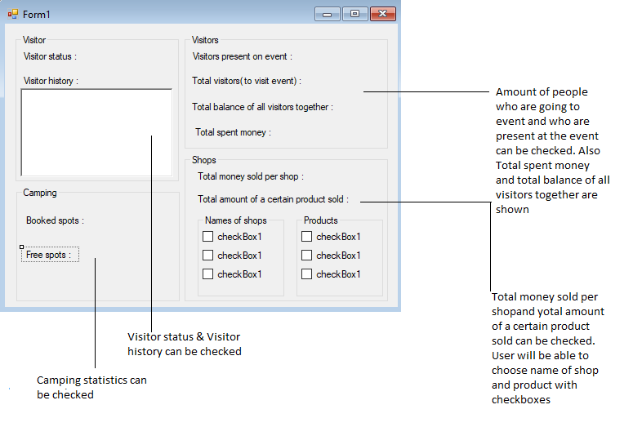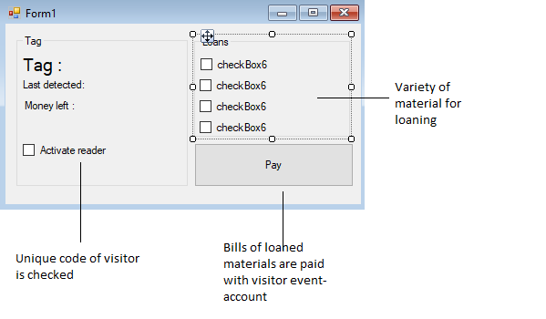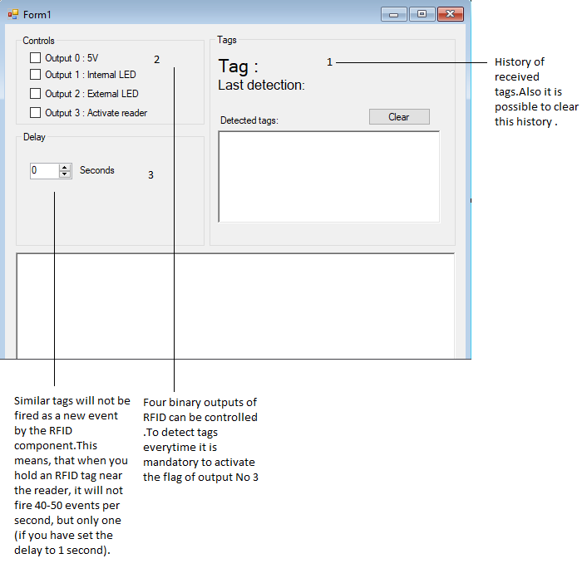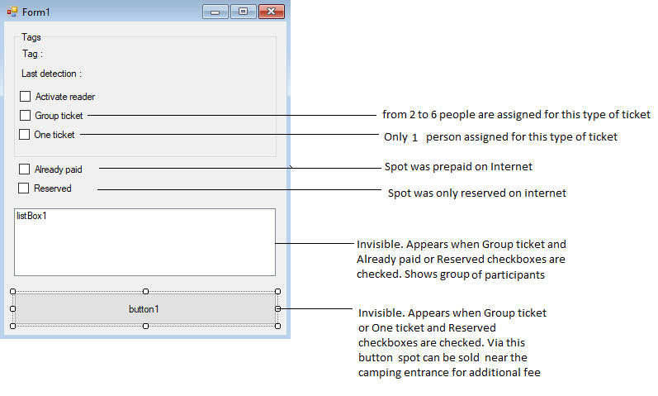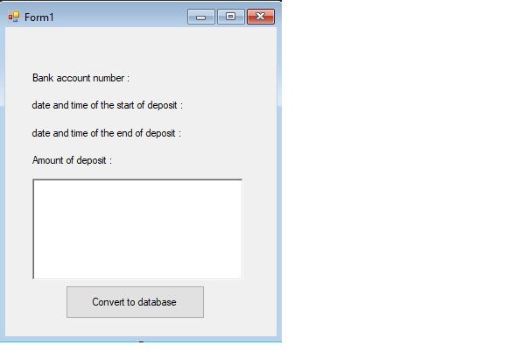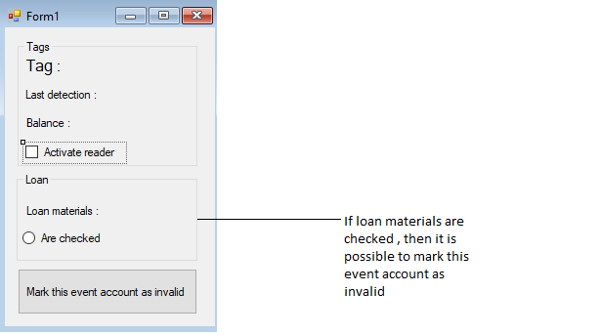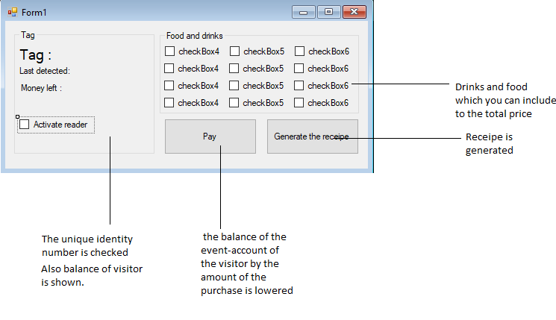

# ERD

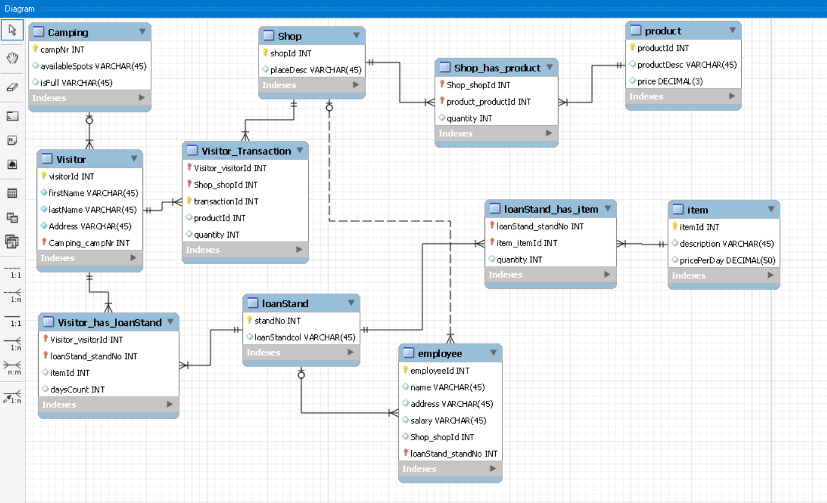

Website wireframe